**1) mongoimport tool**

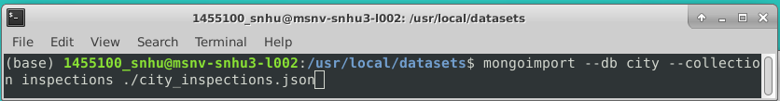

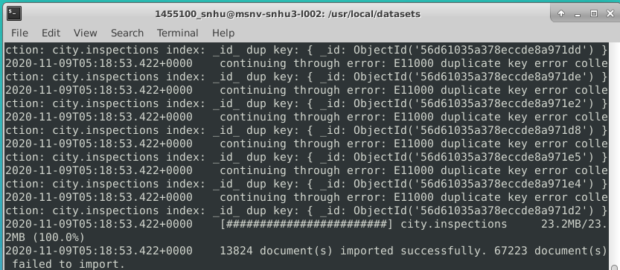

**2a) Verify … find 🡪 “id” : “10021-2015-ENFO”**

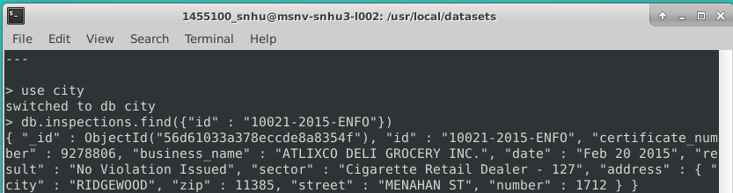

**2b) Verify … find 🡪 “result” : “Out of Business”**

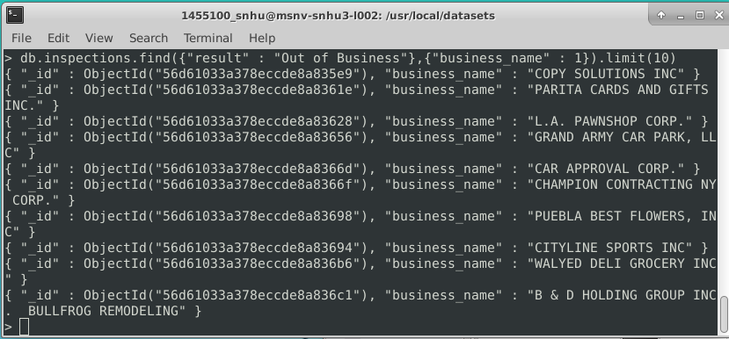

**3) Insert a document**

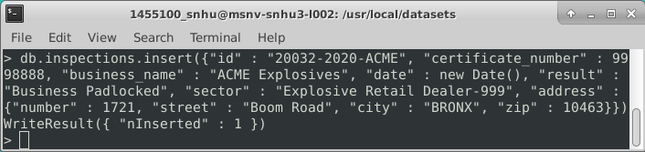

**Verify –** checked timestamp on “_id” and confirmed my document is ObjectId(“5fa8dba127da4aeaefa2cc92”)

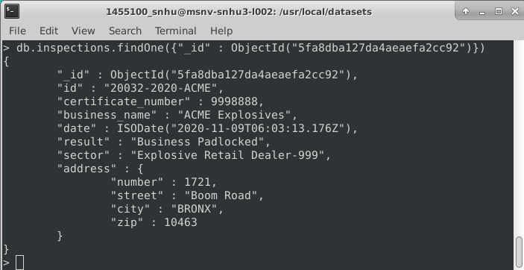

**4a) Distinct list “sector”**

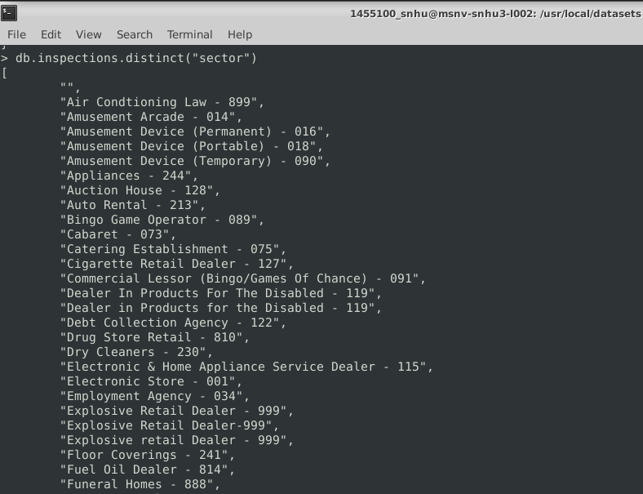

**How many are in the list?**

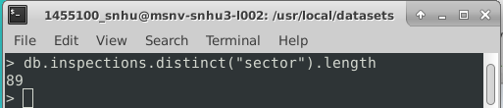

**4b) Difference between DATE data types:**

* **The data type for the *date* field on “AUSTIN 2012” is most likely a string literal in the form “Month DD YYYY”**
* **The data type for the *date* field on my document is an ISODate**

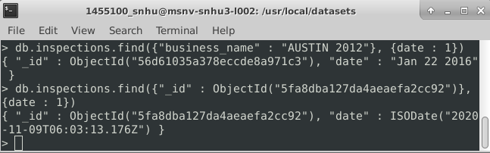

**4c) “Violation Issued” count:**

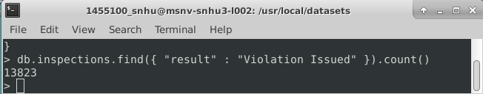

**5) Update document & Verify**

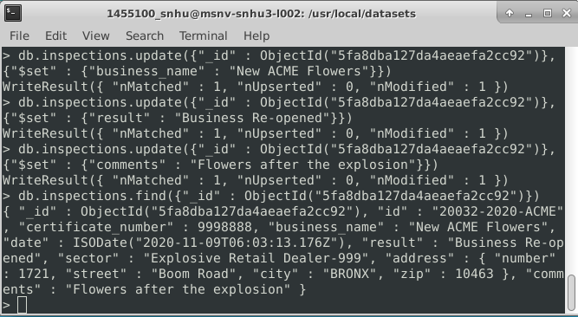

**6a) Update Zip for All Documents 🡪 “city” : “ROSEDALE”**

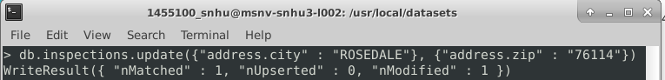

**Verify:**

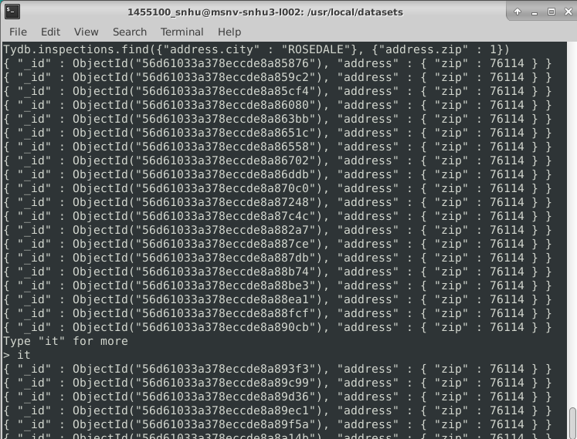

**More Verify:**

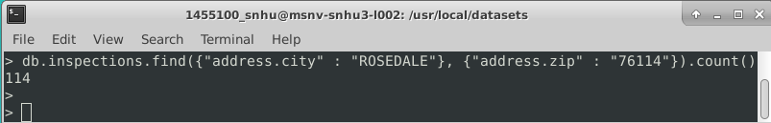

**6b) Remove 1st document 🡪 “result” : “Violation Issued” & Verify:**

